Programming Assignment Unit 7
- Write a program in PHP using a ‘for’ loop to add all the integers between 0 and 50 and display the total.
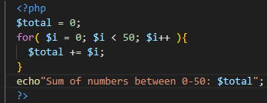
- Write a PHP program to check if a person is eligible to vote using control structure. (Criteria: Minimum age required to vote is 18)
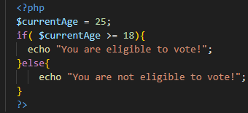
- Write a PHP program to check whether a number is prime or not.
